Modelling:

Models can be based on equation, data.

Different types of modelling using Simulink:

i) Mathematical Models (Writing equations)

1.First Principles

2.Component-based physical models

ii) Black Box Models (Solely based on input and output data)

1.Lookup Tables

2.System Identification *(Dynamically changing functions using curve fitting)

iii)Grey Box Models (We know some eqns. but not sure about the parameters so we write eqns. and collect data so that the data can be used to tune the parameters)

1.Parameter estimation*

*Powerful tools

Models can be generally divided into 2 parts:

i) Plant Model- Virtual Prototype of a real physical System and these systems can be modelled with the help of data collected from the real system (or) getting the mathematical equation from physics

ii) Algorithm- Control and Logic systems, Design in Simulink and then generate code for the embedded system

Simulink helps us to combine these 2 parts

Suspension System of Cars:

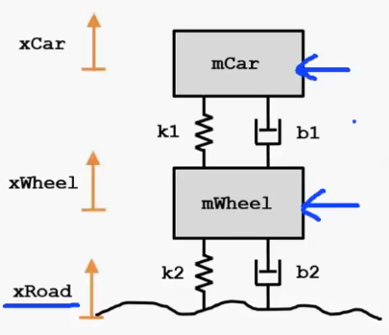

There is assumed to be one extra set of spring and damper one between the wheel and the road and the other which is physically present

This is done in real cars because to account for the wheel squishing against the road, but we can choose to neglect this in shadow bot

**Mathematical Modelling of Car suspension:**

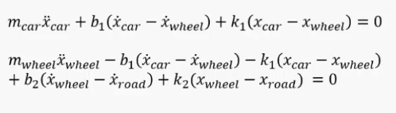

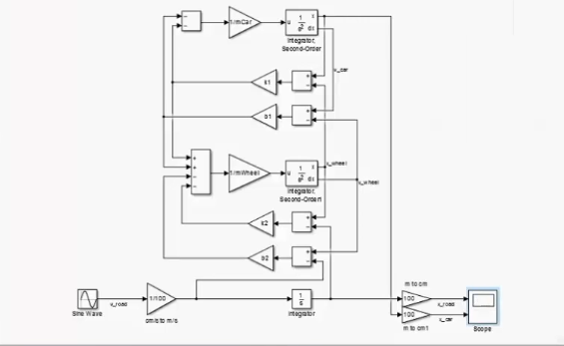

Instead of this type of modelling we can also use transfer functions or state space model

State Space Model:

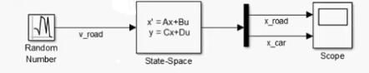

We can see that the previously huge block became a linear one

The state-space block contains the equation in 4 matrices (A, B, C, D)

**Component Based Modelling (Simscape):**

Simscape a tool for physical modelling which has blocks which has the equations inside it i.e. we don’t need to know the equations and if there are any changes in the system then we don’t need to re formulate the eqns. again from scratch we can just alter the blocks

Both Simulink and Simscape are compatible i.e. we can integrate plant model in Simscape and control in Simulink with the help of interface blocks

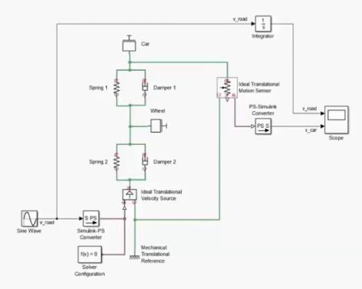

**Black Box Approach:**

We have this data:

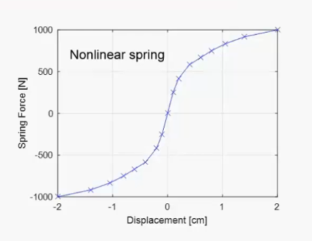

We can import data from excel sheets or text file

We simply insert a block stating the parameters from the file which has the plots

**Parameter Estimation:**

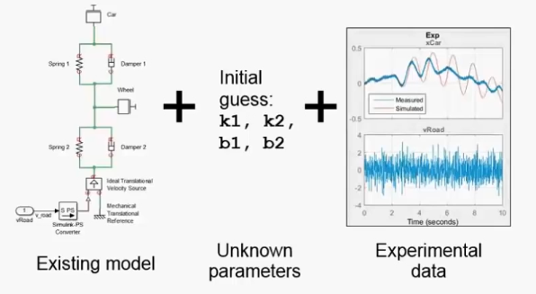

Still more to come